**Assignment Part B**

**Request for Proposal (RFP)**

**End-to-End Business Management Platform**

**Issue Date:**6th April 2025

**Contact Person:**Muhammad Sheheryar Tariq  
+61 437 311 765

**Table of Contents**

**Quick Facts About RFP 3**

**About ABB 3**

Company Overview 3

Current Operations 4

Future Company Plans 4

**Contact Info 5**

**Proposal Evaluation Criteria 5**

[Technical Evaluation Criteria  
System Functionality 5](#_on7dq5q4x1cr)

Scalability and Flexibility 5

Integration Capabilities 5

Security and Compliance 6

Financial Evaluation Criteria 6

Cost Structure 6

Return on Investment (ROI) 6

Vendor Evaluation Criteria 6

Company Experience and References 6

Project Team and Skillset 6

Implementation and Support Evaluation Criteria 6

Timeline and Project Plan 6

Post-Deployment Support 6

**Project Summary 7**

**Target Market 7**

Key Customers 7

Marketing Channels 7

Geographic Reach 7

Market Needs 7

Primary Goal 8

Secondary Goals 8

Budget and Timeframe 8

Estimated Budget 8

Expected Timeline 8

Timeline Considerations 9

Business Requirements 9

Functional Requirements 10

Creative Requirements 11

User Experience (UX) Design 11

Customizability and Personalization 12

Brand Consistency 12

Responsiveness and Device Compatibility 12

Accessibility and Inclusivity 12

Onboarding and Help Design 13

Design Inspiration Sources 13

Mockups 14

9.4 Existing Technical Environment 15

9.5 Preferred Working Relationship 15

9.6 Support & Maintenance Needs 15

RFP Submission Format and Requirements 16

Additional Considerations 17

Intellectual Property (IP) 17

Confidentiality 17

Budget Flexibility 17

Vendor Presentations 17

Submission Guidelines 17

# Quick Facts About RFP

| **Item** | **Details** |
| --- | --- |
| RFP Title | Integrated Business Management System for Aussie Business Buzz |
| Issuing Organization | Aussie Business Buzz (ABB) |
| RFP Contact | Sheheryar Tariq, Business Systems Manager |
| Contact Email | rfp@aussiebuzz.com.au |
| Response Deadline | May 10, 2025 |
| Expected Start Date | July 1, 2025 |
| Project Duration | Approximately 6 months |
| Submission Format | PDF or Word Document, submitted via email |
| Budget | AUD 200,000–250,000 (flexible depending on scope) |
| Proposal Evaluation Criteria | Functionality, scalability, vendor experience, support, and cost |

# About ABB

## Company Overview

Aussie Business Buzz (ABB) is an Australian-owned technology retailer and service provider, committed to delivering high-quality consumer electronics and after-sales support. With a growing customer base, ABB offers a range of technology products including laptops, PCs, smartphones, networking devices, and accessories. In addition, ABB provides expert repair services and digital device solutions, building a strong reputation for reliability and customer service.

## Current Operations

ABB currently operates **four retail outlets** located in New South Wales and Queensland. Each location handles:

* Direct sales of tech products and accessories
* Device repair services and maintenance
* Customer service and consultation

These stores operate semi-independently with **local inventory and records**, but currently lack a unified system for managing:

* Customer relationship data
* Inventory and parts
* Repair workflows
* Marketing campaigns
* Business reporting

Marketing efforts are mostly **manual** or done through basic tools (e.g., Excel, basic email campaigns), and reporting is compiled from store-specific data.

## Future Company Plans

ABB envisions rapid expansion across Australia over the next 2–3 years, aiming to increase from 4 to **12 branches**. To support this growth, ABB plans to:

* Centralize and automate inventory and stock management across all branches
* Introduce a CRM for customer insights and streamlined support
* Integrate digital marketing capabilities to increase customer retention and reach new audiences
* Enable remote access to business intelligence dashboards for executive teams

The integrated business management system requested in this RFP is a **critical first step** toward scaling operations and improving internal efficiencies.

# Contact Info

All inquiries related to this RFP must be directed to the designated point of contact below:

**Primary Contact:** **Name:** Sheheryar Tariq  
 **Position:** Focal Point – Business Systems Procurement  
 **Phone:** +61 487 384 124  
 **Email:** sheheryartariq@ymail.com

Vendors may reach out via email for clarification or additional information regarding the RFP. A response to all inquiries will be provided within 2 business days. The deadline for submitting questions is **May 5, 2025**.

# Proposal Evaluation Criteria

Proposals submitted in response to this RFP will be evaluated based on the following criteria. Each proposal will be scored and ranked according to its ability to meet the business objectives outlined in this document.

### **Technical Evaluation Criteria** **System Functionality**

* How well the proposed system addresses the functional needs of ABB (CRM, marketing, inventory, reporting).
* Compatibility with ABB’s existing and future technical environment.

### Scalability and Flexibility

* Ability to support business growth (e.g., from 4 to 12+ locations).
* Customizability of the platform for future enhancements or modules.

### Integration Capabilities

* Ease of integrating with ABB’s existing tools (e.g., website form submissions, email platforms).
* APIs or middleware support for data migration and third-party systems.

### Security and Compliance

* Measures in place for data protection, access control, and user permissions.
* Compliance with Australian data regulations and privacy laws.

### Financial Evaluation Criteria

### Cost Structure

* Total project cost (initial setup, licensing, third-party tools).
* Transparency of pricing (one-time costs, subscriptions, hidden fees).

### Return on Investment (ROI)

* Potential cost savings or revenue growth facilitated by the system.
* Efficiency improvements and reduction of manual work.

### Vendor Evaluation Criteria

### Company Experience and References

* Previous experience with similar projects or clients in retail or tech.
* Client testimonials, references, or case studies.

### Project Team and Skillset

* Qualifications and roles of the project team.
* Access to post-launch technical support or customer success staff.

### Implementation and Support Evaluation Criteria

### Timeline and Project Plan

* Proposed milestones, development phases, and estimated completion date.

### Post-Deployment Support

* Ongoing maintenance options
* Service Level Agreements (SLAs) and response times

# Project Summary

Aussie Business Buzz (ABB) is seeking proposals for an Integrated Business Management System to unify operations across its four branches. The system should handle customer relationships, marketing campaigns, inventory management, repair tracking, and centralized reporting.

This solution will replace ABB's current fragmented tools, aiming to increase efficiency, reduce manual work, and support future expansion. Proposals may include custom software, existing applications, SaaS platforms, or hybrid approaches. The ideal system must be secure, user-friendly, and scalable.

# Target Market

### Key Customers

ABB serves individual customers purchasing devices or accessing repair services, as well as small businesses that rely on ABB for technology products and basic IT support.

### Marketing Channels

ABB promotes its services through digital marketing, including email and social media, along with in-store promotions and loyalty initiatives. The company also collects leads through its existing website.

### Geographic Reach

The business currently operates in New South Wales and Queensland. As part of its expansion plan, ABB aims to establish a nationwide presence over the next two years.

### Market Needs

Customers expect real-time stock availability, personalized communication, and efficient service tracking. Internally, ABB needs centralized data and reporting to support strategic decision-making and day-to-day operations.

**Project Overview**

## Primary Goal

The primary goal is to implement a centralized system that connects customer management, inventory tracking, repair workflows, marketing activities, and reporting across all ABB locations. This will enhance operational efficiency and provide better visibility into business performance.

## Secondary Goals

Secondary goals include improving customer communication through targeted marketing, enabling real-time stock visibility across branches, and simplifying internal processes to support ABB’s expansion plans.

## Budget and Timeframe

### Estimated Budget

ABB has allocated a flexible budget for the development and implementation of the integrated system. The budget range reflects the anticipated scope of work and quality of solution required.  
  
Project Phases and Timeline - Aussie Business Buzz

| **Phase** | **Timeline** | **Description** |
| --- | --- | --- |
| Vendor Selection | May 2025 | Proposal evaluation and contract award |
| Project Kick-off | July 1, 2025 | Requirements finalization and onboarding |
| Design & Prototyping | July – August 2025 | UI/UX and workflow designs |
| Development | August – October 2025 | Core feature development and integration |
| Testing & Feedback | November 2025 | QA, UAT, and adjustments |
| Final Deployment | December 2025 | Full system rollout across all branches |
| Post-launch Support | Jan – June 2026 | Monitoring, bug fixes, and performance tuning |

* **Range:** AUD 200,000 – 250,000
* **Inclusions:** Design, development, testing, deployment, training, documentation, and 6 months of post-launch support
* **Exclusions:** Long-term licensing (beyond 6 months), optional third-party tools not essential to core functionality

### Expected Timeline

The timeline for the project is structured to allow a complete rollout within six months from the contract start date. Key milestones are outlined below:

### Timeline Considerations

* Vendors may propose an accelerated schedule if feasible.
* ABB prefers a phased delivery model to minimize disruption to ongoing operations.
* Regular progress check-ins and demos will be required throughout the timeline.

**Business and Technical Requirements**

## Business Requirements

Aussie Business Buzz (ABB) requires a robust system that enhances operational efficiency, provides a seamless customer experience, and supports future business growth. The system should:

* Centralize customer data across all branches
* Improve repair tracking, turnaround times, and service transparency
* Provide real-time inventory visibility and automate stock reordering
* Enable targeted marketing based on customer preferences and purchase history
* Offer remote access to reports and dashboards for management decision-making

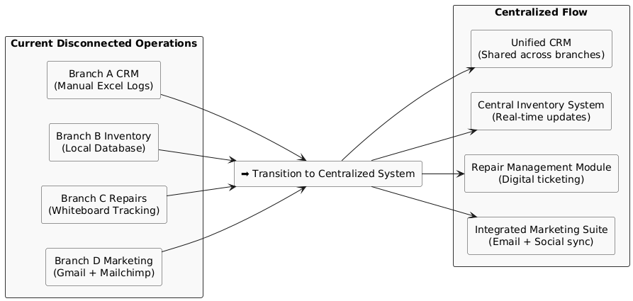

## Functional Requirements

The proposed system should support the following core functional modules to streamline operations across ABB’s retail and service branches:

| **Module** | **Feature** | **Description** |
| --- | --- | --- |
| **Customer Relationship Management (CRM)** | Customer Profiles | Maintain detailed customer records, including contact info, preferences, and history. |
|  | Purchase History | Track all product and service purchases per customer across locations. |
|  | Service Records | Store past and ongoing repair/service information linked to each customer. |
|  | Follow-up & Reminders | Automated notifications for post-repair check-ins, warranty reminders, etc. |
| **Repair Management** | Repair Tickets | Digitally log each device repair request with issue descriptions and timestamps. |
|  | Repair Status Tracking | Real-time status updates (e.g., Received → Diagnosing → Repaired → Ready). |
|  | Technician Assignment | Assign repair jobs to in-store technicians with priority and estimated time. |
|  | Repair Logs | Maintain a record of diagnostic notes, parts used, and service performed. |
| **Inventory Management** | Centralized Inventory | Unified stock database accessible by all branches for real-time tracking. |
|  | Branch-specific Inventory | Track available inventory per location, including reserved or damaged items. |
|  | Low Stock Alerts | Notifications for low or out-of-stock items based on predefined thresholds. |
|  | Automatic Reordering | Trigger purchase orders from approved suppliers based on inventory rules. |
|  | Vendor Integration | Connect with external suppliers via API or upload CSV for order placements. |
| **Marketing Automation** | Campaign Management | Create and send email/SMS/social campaigns from a single interface. |
|  | Contact Segmentation | Segment customers by purchase history, region, interest, or activity. |
|  | Schedule & Trigger Campaigns | Automate campaigns based on customer behavior or key dates. |
|  | Campaign Performance Tracking | View open rates, click-through rates, and conversions by campaign. |
| **Reports & Analytics** | Sales Analytics | Visual reports for product sales trends by branch, category, or period. |
|  | Repair Turnaround Metrics | Track average repair times, technician performance, and bottlenecks. |
|  | Inventory Reports | Analyze fast-moving items, slow stock, and out-of-stock trends. |
|  | Marketing Reports | Evaluate effectiveness of campaigns and ROI from promotions. |
|  | Exportable Dashboards | Export data to PDF, Excel, or live links for sharing with management. |
| **Admin Panel** | Role-based Access | Define user roles (Admin, Technician, Staff) with permission control. |
|  | Multi-branch Management | Add/edit/view branch-specific data with centralized oversight. |
|  | Audit Logs | Maintain a secure log of all actions performed for compliance and rollback. |
|  | Settings Management | Configure system-level settings, branch preferences, templates, etc. |

## Creative Requirements

The proposed system should feature a **visually consistent, user-friendly interface** that reflects ABB’s brand identity and is accessible to users of all technical backgrounds. Design quality is critical to ensure high adoption rates across different branches and user roles.

### User Experience (UX) Design

The system must prioritize simplicity, clarity, and ease of navigation. Users should be able to complete key tasks such as logging repairs, checking inventory, or launching a marketing campaign with minimal steps.

* Interfaces must be **intuitive**, with logically grouped features and minimal cognitive load.
* A **dashboard-first layout** should present important metrics and actions on one screen.
* Key tasks should follow **consistent design patterns** across modules to reduce learning time.

### Customizability and Personalization

The system should allow some level of customization based on the user role and branch-specific preferences.

* **Customizable dashboards** (e.g., reorder widgets, select favorite reports, toggle views)
* Support for **user profiles** with preferences like theme settings and saved filters

### Brand Consistency

ABB has an established brand identity that the platform should reflect to reinforce professionalism and trust.

* Use ABB’s **official brand colors, fonts, and logos**, which will be provided upon onboarding
* Visual elements should follow **modern design standards**, avoiding outdated or cluttered aesthetics

### Responsiveness and Device Compatibility

As the system will be used on desktops, tablets, and mobile devices in-store, a **responsive layout** is essential.

* Full support for **tablet-based usage** in repair areas and inventory stockrooms
* Mobile-friendly views for quick access on phones by managers or staff
* Responsive behavior across screen sizes, including dynamic resizing of tables and widgets

### Accessibility and Inclusivity

The design must accommodate all users, including those with disabilities.

* Adhere to **WCAG 2.1 AA standards**, ensuring accessibility features like:
  + Sufficient color contrast
  + Text alternatives for icons/images
  + Keyboard navigability
  + Screen reader compatibility
* Use clear, **non-technical language** in labels, tooltips, and instructions

### Onboarding and Help Design

Since not all ABB staff are tech-savvy, the design should support **fast onboarding and self-help**.

* Embedded tooltips, short tutorials, or guided tours for first-time users
* Clear error handling with helpful messages and next steps
* A searchable help center or FAQ accessible from within the interface

### Design Inspiration Sources

Vendors may refer to the following platforms for stylistic and UX inspiration:

* [RepairDesk](https://www.repairdesk.co/) – modern repair ticket interface
* Square Dashboard – intuitive POS and analytics
* [Shopify Admin](https://www.shopify.com/) – clean product/inventory management UI
* Zoho CRM – highly modular CRM layout

### Mockups

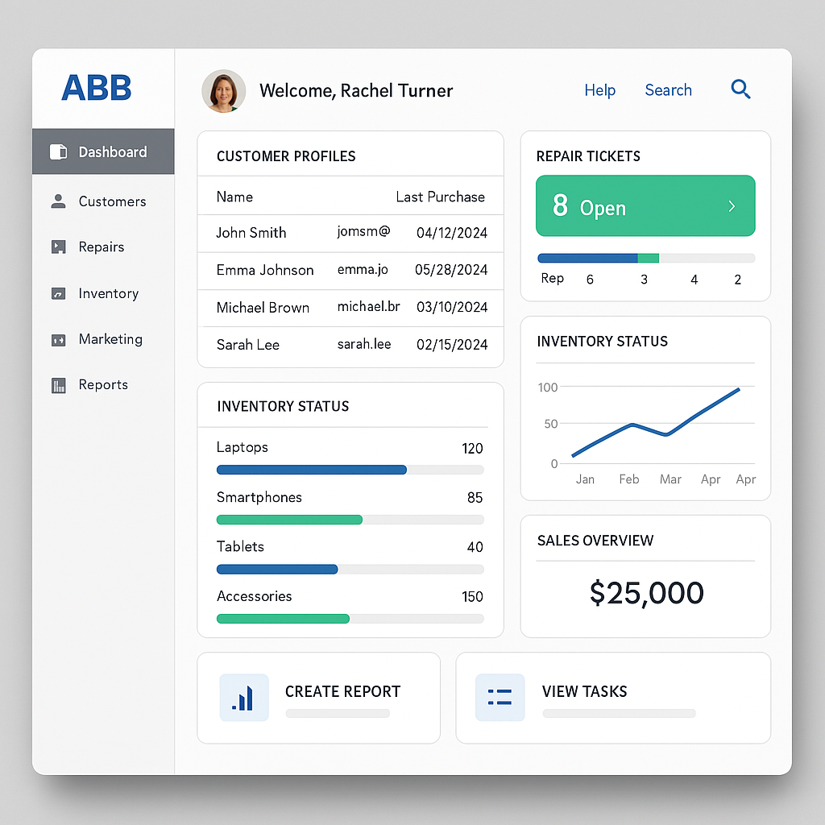

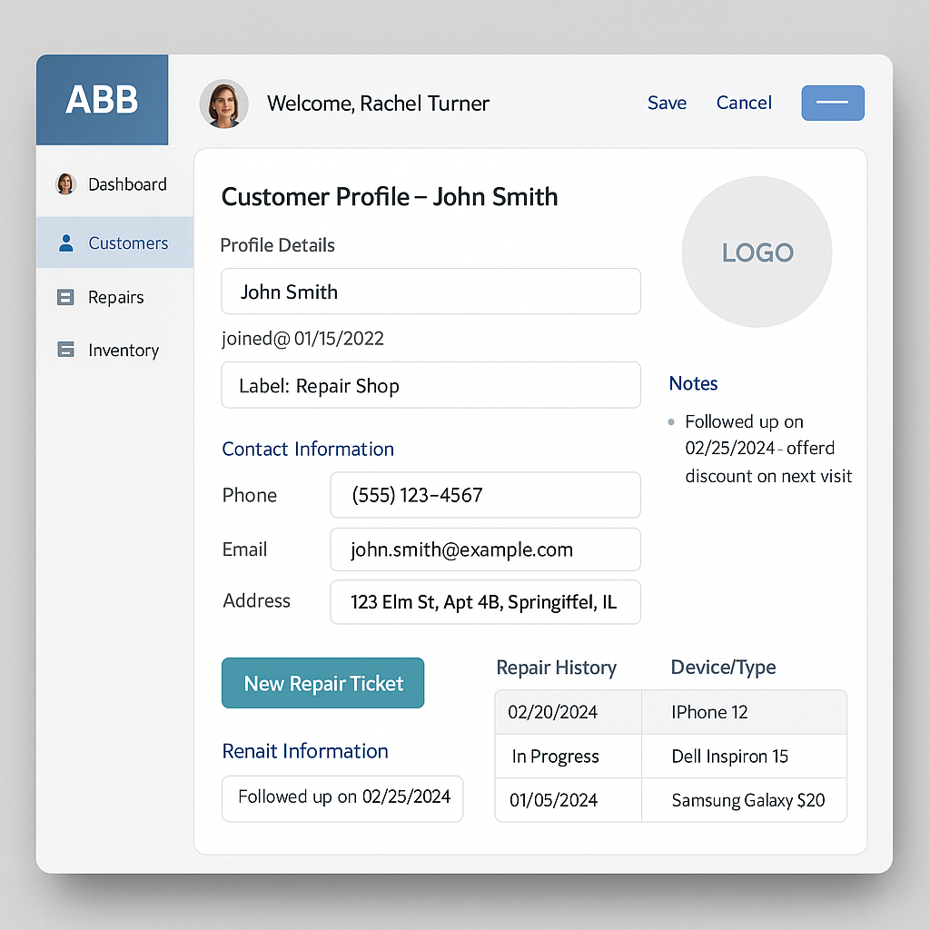

## Existing Technical Environment

ABB’s existing infrastructure includes the following:

* Basic POS systems (non-integrated, Excel-based logs)
* Website hosted on WordPress (used for basic contact capture and blogging)
* Email handled via Gmail and third-party marketing platforms like Mailchimp
* Each store currently stores inventory and sales data locally
* No existing centralized CRM or automated stock management tool

The proposed system must integrate smoothly with ABB’s current website and support **data migration** from legacy systems. APIs or import tools should be provided.

## Preferred Working Relationship

ABB seeks a long-term development partner who offers:

* Transparent communication and project tracking
* Agile development with frequent check-ins and sprint demos
* A dedicated project manager and point of contact
* Openness to co-creation and iterative feedback
* Documentation and knowledge transfer sessions at handoff

Regular progress updates (weekly or bi-weekly), user acceptance testing, and collaborative planning are expected during the development phase.

## Support & Maintenance Needs

ABB requires ongoing support post-deployment for system stability, enhancements, and troubleshooting. Expectations include:

* Initial 6-month support included in the contract
* Defined Service Level Agreements (SLAs) with response times
* Tiered support system (Critical – 24h, Medium – 72h, Low – 5 days)
* Optional add-on for continuous feature improvements or scaling
* Security patches and compliance updates included

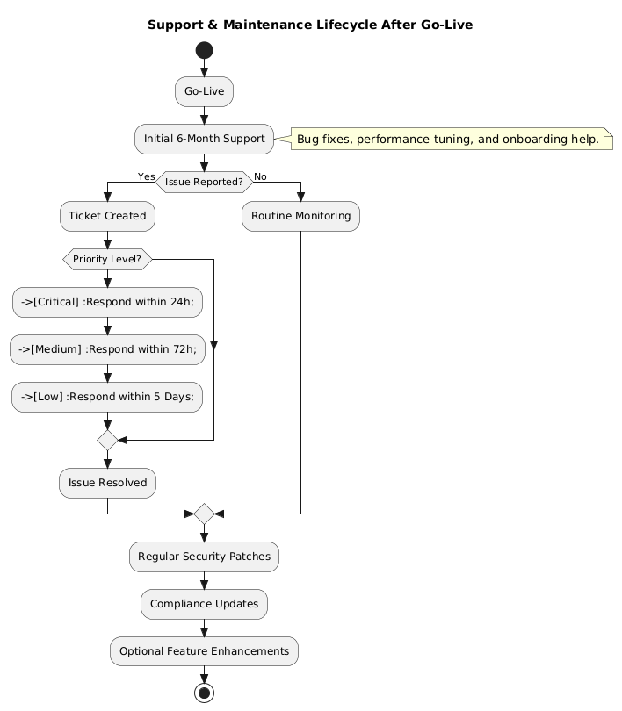

## RFP Submission Format and Requirements

All proposals must be submitted in either PDF or Microsoft Word format and written in English using a clear, readable font. Submissions should be concise and focused, ideally not exceeding 20 pages, excluding annexes such as case studies or visual assets.

The proposal should begin with a brief executive summary, followed by an overview of the vendor’s company and relevant experience. A detailed description of the proposed solution, including its technical and functional capabilities, project timeline, pricing structure, and post-deployment support plan, must be included. Additional supporting materials such as mockups, product walkthrough links, or client references are welcome but not mandatory.

ABB encourages clarity, professionalism, and structure that makes it easy to evaluate proposals side-by-side. All submissions must be complete and delivered by the deadline to be considered.

## Additional Considerations

### Intellectual Property (IP)

All custom code, configurations, and deliverables created for ABB as part of this project will become the intellectual property of ABB, unless otherwise negotiated in writing.

### Confidentiality

All information shared by ABB during this RFP process must remain confidential. Vendors are prohibited from sharing proposal content or ABB information with third parties without written consent.

### Budget Flexibility

ABB has provided a flexible budget estimate to encourage innovative solutions. Creative approaches that deliver strong ROI while meeting core needs are encouraged.

### Vendor Presentations

Shortlisted vendors may be invited to present their solution virtually to ABB’s evaluation panel before final selection.

## Submission Guidelines

* **Submission Deadline:** May 10, 2025 by 5:00 PM AEST
* **Email Submissions To:** sheheryartariq@ymail.com
* **Subject Line Format:** ABB_RFP_YourCompanyName.pdf

Late submissions may not be considered unless prior arrangements have been approved.

For any queries, please contact:  
 **Sheheryar Tariq** Focal Point – Business Systems Procurement  
 📞 +61 487 384 124  
 📧 sheheryartariq@ymail.com

All questions must be submitted by **May 5, 2025**. ABB will respond to all vendors with compiled answers to maintain fairness.